WEEK 3 STATUS REPORT
Project Title:
High Availability Router Project using HSRP and GNS3.
Course:
Computer Networks Lab
Submitted To:
Sir Muhammad Fahad Irshad
Submitted By: (Group 6)
- Sumaiya Bibi F2024266340
- Rameen Junaid F2024266341
- Tayyba Shahzad F2024266348
- Eshmal Zahid F2024266755
Introduction:
This week focused on implementing network security controls and testing their effectiveness. Security verification, ACL planning, attack simulation, packet capture analysis, and mitigation testing were performed. Wireshark was used to capture network traffic before, during, and after mitigation. Access Control Lists (ACLs) were configured to restrict unauthorized ICMP traffic from Kali Linux to Router A.
Objectives:
- Verify existing network connectivity and stability.
- Verify SSH secure remote access.
- Plan and implement ACL security policies.
- Perform attack simulation and traffic analysis.
- Capture network traffic using Wireshark.
- Verify mitigation using ACLs.
- Document security implementation results.

Network Verification:
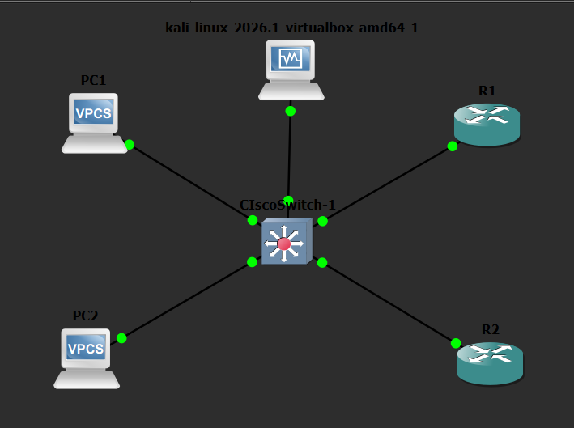
The network topology was verified before implementing security controls. Router interfaces, VLAN configuration, HSRP status, and connectivity between devices were checked successfully. Kali Linux was able to communicate with the network and SSH access was verified.

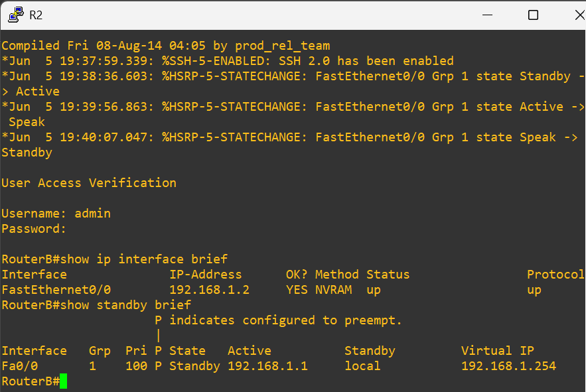
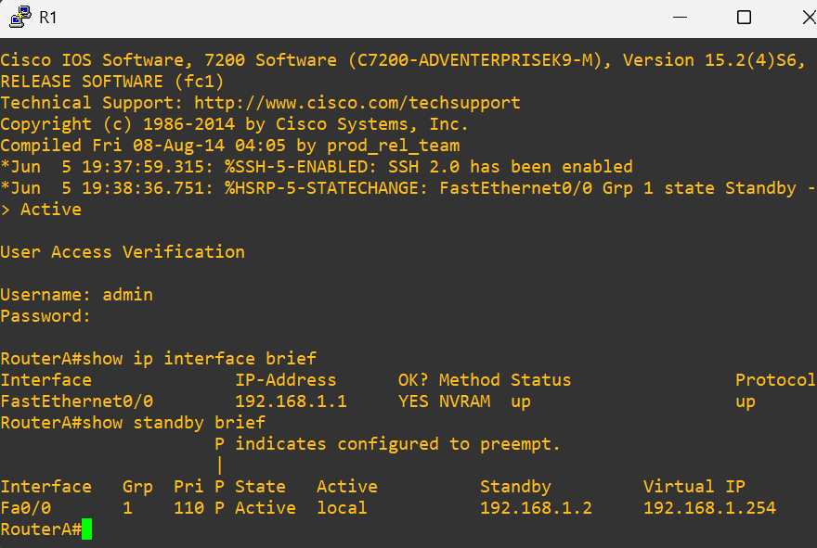
Router A and Router B Verification:

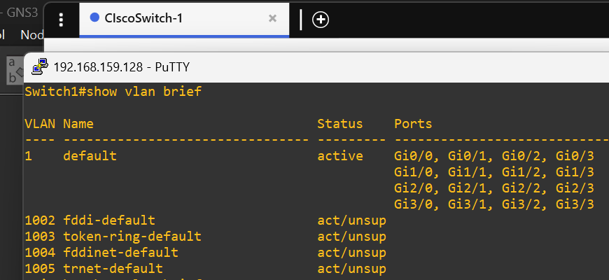
VLAN Verification:

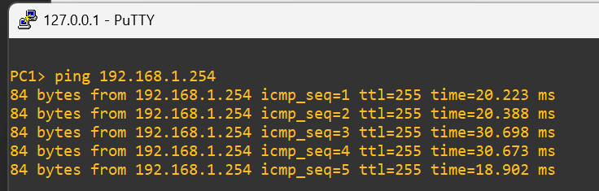
Successful Ping Verification:
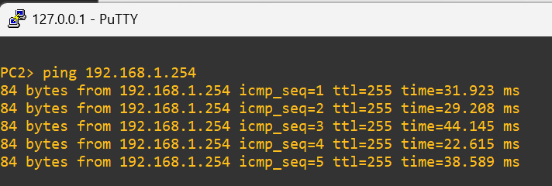

SSH Security Verification:
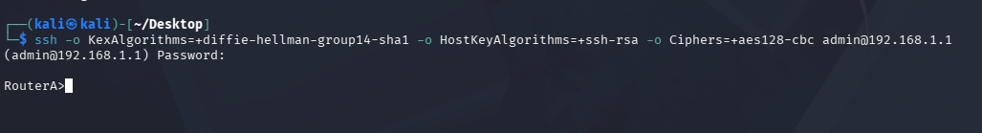
SSH connectivity between Kali Linux and Router A was verified successfully. Authentication was tested using the configured username and password. Router access through SSH confirmed that secure remote management was functioning correctly.
Successful SSH Login:

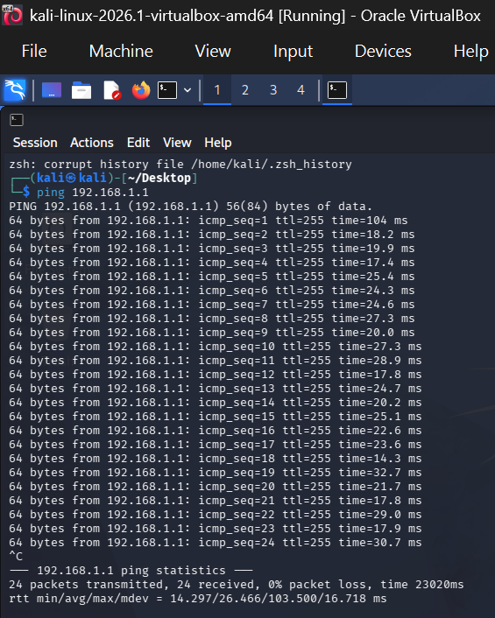

ACL Planning:
An ACL security plan was prepared to restrict unauthorized ICMP traffic originating from Kali Linux. The objective was to demonstrate traffic filtering and attack mitigation while maintaining normal network operations.

Source Device:
Kali Linux (192.168.1.100)
Destination Device:
Router A (192.168.1.1)
Policy:
- Deny ICMP traffic from Kali Linux.
- Permit all other IP traffic.
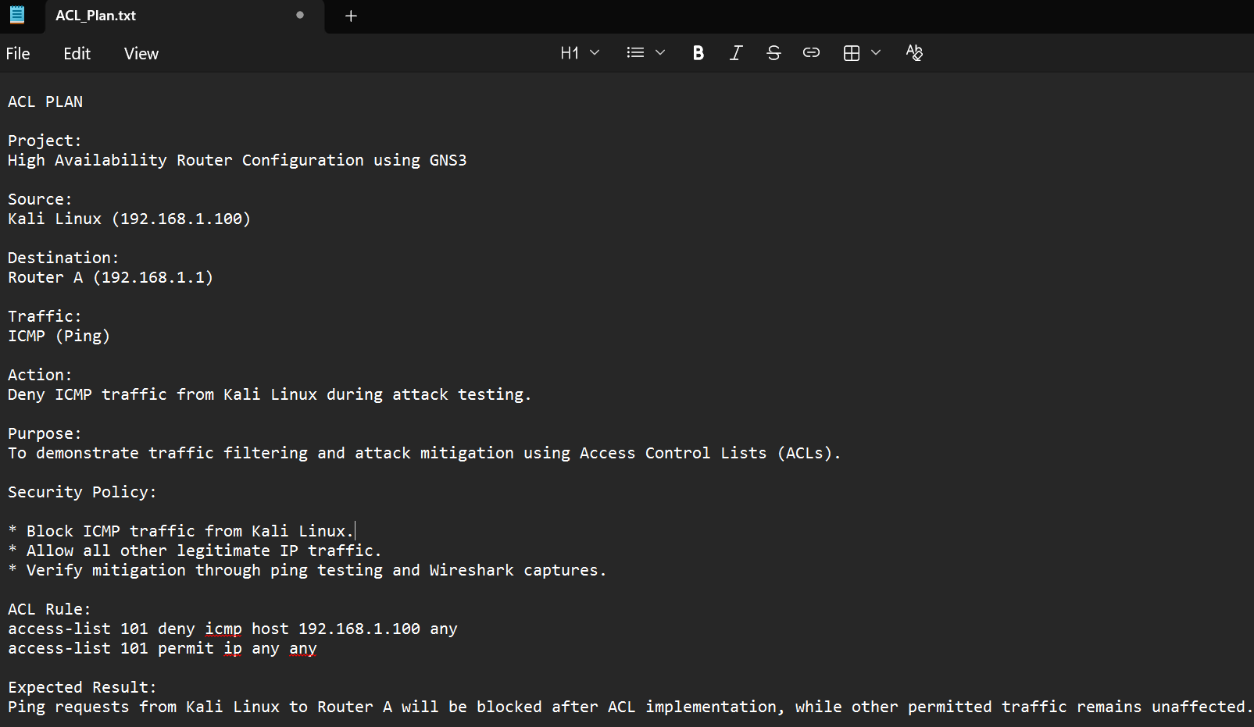

ACL Configuration:
The following ACL was configured on Router A:
access-list 101 deny icmp host 192.168.1.100 any
access-list 101 permit ip any any
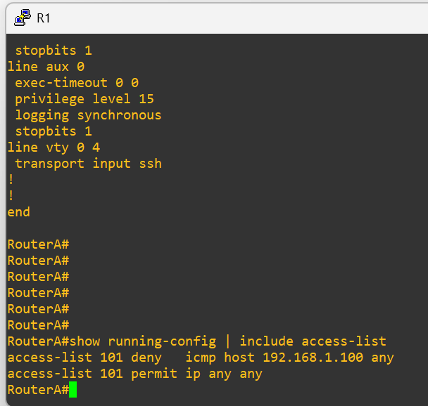
The ACL was applied to the appropriate router interface to filter ICMP traffic from Kali Linux.

Traffic Capture and Attack Simulation:
Wireshark was used to capture network traffic at three different stages.
Pre-Attack Capture:
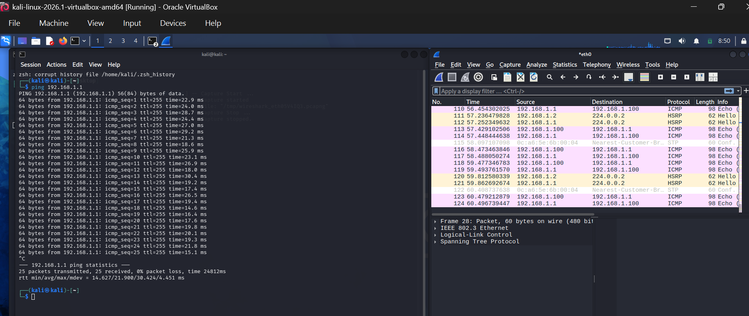
Normal network communication was captured before applying mitigation controls.

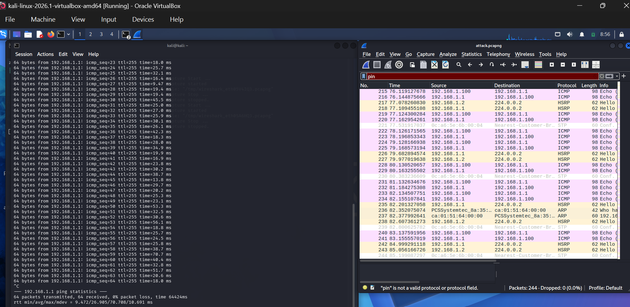
Attack Capture:
Traffic generation and testing were performed while monitoring packet flow using Wireshark.

Post-Mitigation Capture:
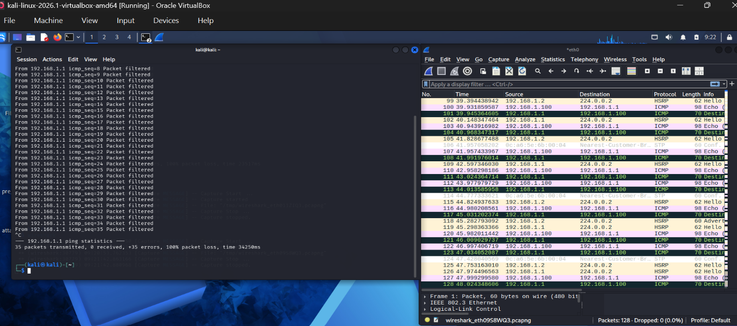
Traffic was captured after ACL implementation to verify that the security policy was functioning correctly.

ACL Verification and Mitigation Results:
ACL verification was performed using router verification commands. After implementation, ICMP traffic from Kali Linux was successfully blocked. Testing results showed packet
filtering and unsuccessful ping attempts, confirming that the ACL mitigation was effective
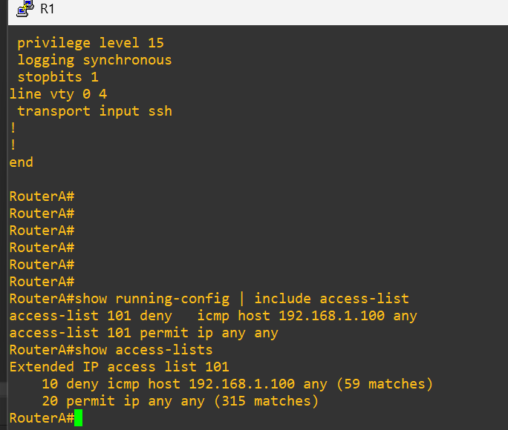
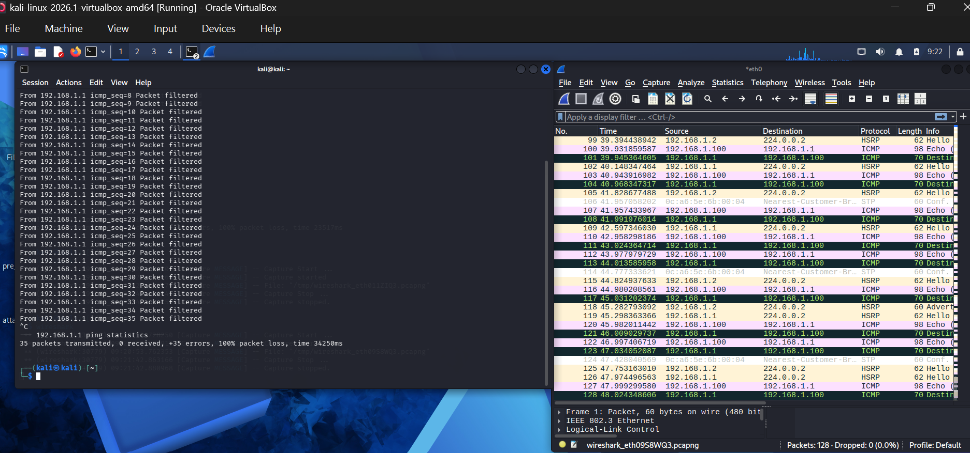


Files Generated:
- ACL_Plan.docx
- pre_attack.pcap
- attack.pcap
- post_mitigation.pcap
- ACL Configuration Screenshot
- ACL Verification Screenshot
- SSH Verification Screenshots
- Network Verification Screenshots
Challenges Faced:
- Initial connectivity issues between Kali Linux and the network.
- SSH compatibility issues during testing.
- Traffic capture and interface selection in Wireshark.
Solutions Applied:
  - Verified IP addressing and routing configurations.
  - Re-established network connectivity through troubleshooting.
  - Verified SSH configuration and authentication settings.
  - Applied ACL policies to restrict unauthorized ICMP traffic.
Conclusion:
Week 3 security objectives were successfully completed. SSH verification, ACL planning, ACL implementation, attack simulation, Wireshark traffic analysis, and mitigation testing were performed successfully. The ACL effectively blocked ICMP traffic from Kali Linux, demonstrating successful implementation of network security controls.

